**PROJECT MANAGEMENT**

**DOCUMENTATION**

**AUTHORS**

**JAKOB | BRAYDEN | ALEX**

**Software Project Management tools**

**Sourcetree:** Sourcetree is one of the software project management tools which would be utilized to increase productivity, collaboration management, and source code control. Sourcetree allows for you to easily interact with your Git repositories on projects so you can modify and create new code and easily push it to your team. Sourcetree provides Source code control to allow teams to view and keep track of changes to the code. This allows members to easily check back at old code and compare the differences letting them see the changes which have been made.

**Microsoft project:** Microsoft is another software project management tool which we would utilize to help organise and focus the team. Microsoft project developed by Microsoft is primarily designed to help the project manager in developing a plan, managing the budget, and attaching people or resources to tasks. We will use Microsoft project to find the estimated cost, time and features for the project we will be undertaking. This will give the whole development team a better understanding of when features have to get done and what to do after that task. This will increase productivity and team management while decreasing confusion throughout development since everyone will have a clear understanding of the deadlines and features which they must do.

**JIRA:** JIRA is another great software project management tool which we could use in the development of the project. JIRA is an issue and feature tracking product developed by Atlassian. JIRA provides an easy to use interface which provides bug tracking, issue tracking and requested features/updates to parts of the project. JIRA is great for collaboration management since everyone on the team can view small posts from each other about the current bugs, issues or requests and their priority. Once a team member decides to take on the challenge of fixing an issue someone else has put on to the board it will be marked with them working on that certain issue. Using JIRA allows the team to very easily see what need to be changed, added, who requested it and who will be working on the issue. JIRA will increase productivity by improving communication to give team members instant updates on work which must get done and how important that issue/feature might be.

**Report Methodology**

Methodology we will or would be utilising for the development of the project consist of gathering information and data through interviews with the client to understand what is necessary and required for the development. Research will also be conducted and we will be searching for similar projects conducted, looking for costs and quality of the product. By doing this it will give our team a better guideline for the industry standard for the task we are taking on, and how to better prepare and plan. To avoid source code conflicts we are making sure when committing we are all informed before we have started on the certain commit, there will concurrent updates to our fellow teammates, till the certain commit is finished. Then as a team we also make sure not to be working on the same commit together, commits must be split as if they are both being done at the same time there could be a commit confliction and an unsuccessful merge. Source Code Control is extremely important when it comes to having a successful project and getting your project to work successfully.

**Project Plan:**

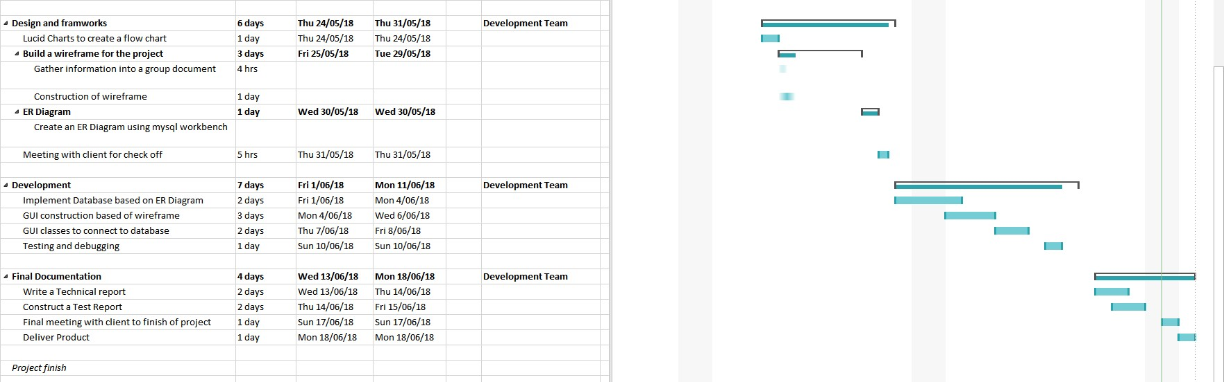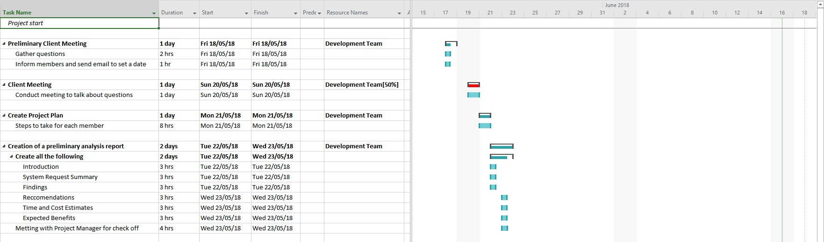

**Demonstrating use of the selected project management, source code control and collaboration software**

**Project Results**

The final project results for our application development has been a successful but challenging task to undertake. The team has found that the initial planning phases which were completed before the development of the project was a big help towards completing the task on time and done so with a high-quality finish. This is not to say there has been no challenges and adjustments made throughout the development of the project. An issue which we had to overcome was getting the login page to work correctly. We were having trouble with the error page displaying when the user enters incorrect values or data which was not in the database. We finally overcame this issue by collectively working as a team, utilizing NetBeans Debugging tools and research to fix the issue. Adjustments made to the project would be the time which it took to finish certain features. Some features took longer than expected to complete so adjustments had to be made to the timeline to fit the delays.

**Review of management tools**

The management tools used have been effective at increasing productivity, team effort and cooperation. The tools utilized Sourcetree and Microsoft Project have been used throughout the development of the application and have had their pros and cons. The pros of the management tools used is that with their easy to use UI and features it has allowed for increased productivity for the development of the application and allowing for quality source code control to view changes and modifications by team members.

**Refrences**

Sourcetree - <https://en.wikipedia.org/wiki/Atlassian>

Sourcetree - <https://sagittarius.agency/blog/5-reasons-to-use-sourcetree-for-git>

Microsoft Project - <https://en.wikipedia.org/wiki/Microsoft_Project>

Microsoft Project - <https://www.mpug.com/education/what-is-microsoft-project/>

Jira - <https://en.wikipedia.org/wiki/Jira_(software)>

Jira - <https://www.atlassian.com/software/jira/agile>

GUI - <https://netbeans.org/kb/docs/java/gui-functionality.html>

GUI - <https://www.cse.wustl.edu~cytron/101Pages/swf12/HelpDocs/NetBeans/netbeanstutorial.htm>

GUI - <https://www.slideshare.net/ewinrosseneriaxl/netbeans-gui-tutorial>

Database - <https://netbeans.org/kb/docs/ide/java-db.html>

Database - <https://netbeans.org/kb/docs/ide/mysql.html>

Database - <https://www3.ntu.edu.sg/home/ehchua/programming/java/JDBC_Basic.html>

OTHERS -

<https://www.w3schools.com/>

<https://www.codecademy.com/learn/learn-java>

<https://netbeans.org/>